ARTIST OF THE MONTH January 2024
Artist of the month is a competition that runs in school. Each month we look at a different artist and their work, children can then respond to this artist by either creating a picture, taking a photograph, writing a story, doing some research or a different response that inspires them. Mrs Britten our Art and Design subject lead shares the artist of the month via the school art notice board. The artist of the month winner will be announced at the end of each month.
To enter you need to respond to the artist however you choose. Put your entry into the basket next to the art cabinet next to the staff room or email it to enquiries@williamgilbertend.derbyshire.sch.uk with the title 'Artist of the Month'.
This month's artist is: Karel Appel 1921-2006

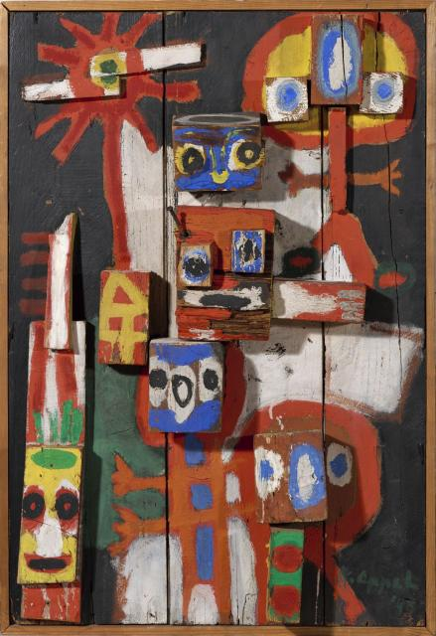 | 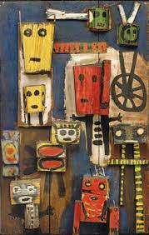 | 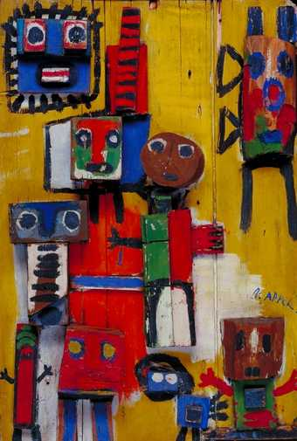
‘Questioning Children’ (1948) | ‘le cheval mourant’ (1956) | ‘Questioning Children’ (1949)

Christiaan Karel Appel was a Dutch painter, sculptor, and poet. He started painting at the age of fourteen and studied at the Rijksakademie in Amsterdam in the 1940s. Karel Appel’s paintings may look like they’ve been painted by a child – and that’s the idea. Karel Appel liked children’s paintings.

He liked the way that children don’t spend too long thinking about how a picture looks, or what colours they will use and just use their instincts. He thought adults should try using their instincts more too.

Karel liked to experiment with different types of canvases. Sometimes he painted on wood, and sometimes he included bits of cork or timber in his works. Like in the painting called ‘Questioning Children.’ You can see that Appel has nailed bits of wood to an old window shutter, and then painted the wood to look like funny creatures. It is quite a sad painting, because when Karel Appel was making it, he was thinking about all the poor children he had seen begging in Germany after the Second World War.

Follow the link to take you to the TATE KIDS website to find out more about Karel Appel.
https://www.tate.org.uk/kids/explore/who-is/who-karel-appel

This month why not have a go at making your own painted relief of your family and friends using cardboard boxes, scraps of wood, corks and even tree bark. Turn the boxes inside out so that the glossy side is on the inside. You will then be able to paint the plain boxes with bright colours. I look forward to seeing your creations.

Here is an idea to help you have fun to create your own Karel Appel inspired piece of art. A 3D piece of work would be amazing.

