 | William Gilbert Endowed  (Church of England)  Primary School & Nursery  Vicarage Lane, Duffield, Belper, Derbyshire,  DE56 4EB  Telephone & Fax: 01332 840395  E-mail: enquiries@williamgilbertend.derbyshire.sch.uk  Headteacher: Mrs E H Britten | 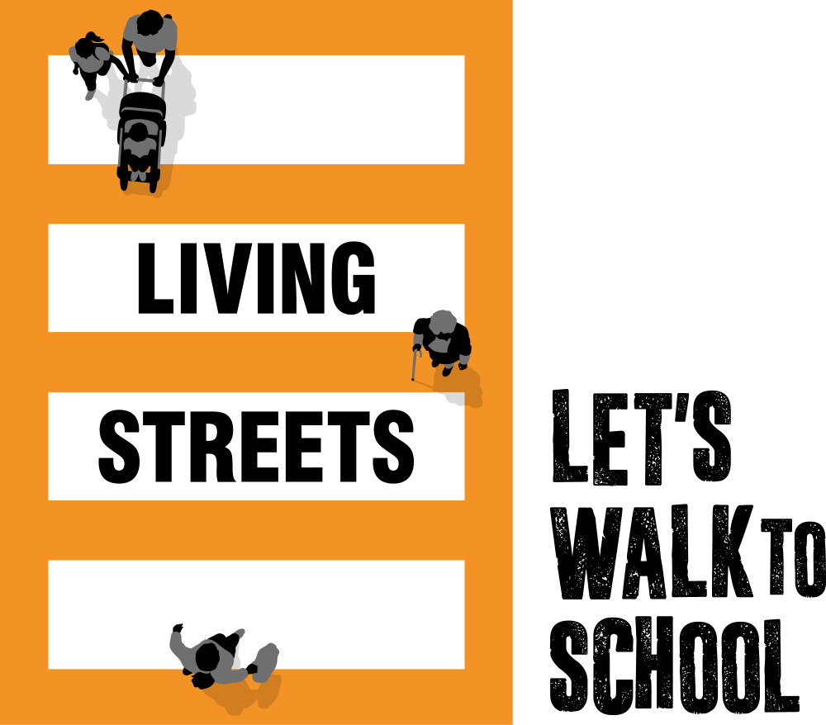  

17th December 2025

Dear Parents and Carers

Living Streets – Let’s Walk to School!

We were visited by a Living Streets coordinator today. They led an assembly to share the news that we have been chosen to be part of an exciting initiative to encourage more children and their families to walk to school.

WOW – the walk to school challenge is delivered by Living Streets, the UK charity for everyday walking, to help as many children as possible experience the benefits of walking or wheeling to school.

The pupil-led challenge enables children to self-report how they get to school every day. If they travel actively (walk/wheel, cycle, scoot, ‘Park and Stride’ or hop off) twice a week, for a month, they get rewarded with a badge. It’s that simple! I have attached a poster with images of some of the badges that can be awarded. During the assembly some children were given vintage WOW badges for their fantastic contributions.

What are the benefits of walking to school?
- Children feel happier and healthier
- They arrive at school refreshed and ready to learn
- Helps reduce congestion and pollution at the school gates
- The roads closest are school are safer for all children

What if we can’t walk to school?
If driving, Park and Stride’ to help your child earn their WOW badges. Park at least ten minutes away from the school and walk or wheel the remaining journey.

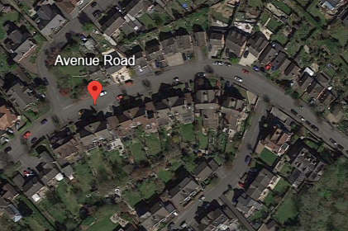
Please find below our schools designated ‘Park and Stride’ locations
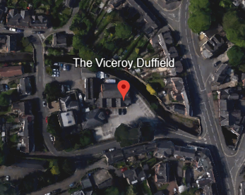
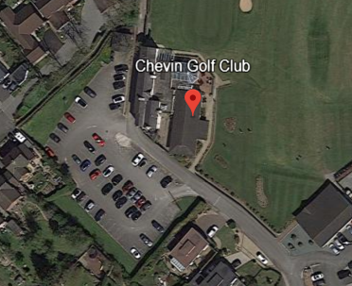
Chevin Golf Club car park | The Viceroy Restaurant car park | Avenue Road
DE56 4EE | DE56 4ER | DE56 4DW

If using public transport, hop off at least ten minutes away and walk the rest of the way (recorded as ‘other’ on the WOW Travel Tracker).

Where walking to school isn’t an option, Living Streets work with schools to establish a bespoke approach to WOW that works best for their pupils’ needs. This includes pupils becoming WOW Ambassadors, leading assemblies, creating active travel notice boards, and other activities within the school day.

If you have any questions on the adaptability of WOW or have suggestions of how we can improve, we would love to hear your thoughts. Please email walktoschool@livingstreets.org.uk

What is a WOW badge?
There are 11 badges to be earned from September 2025 – July 2026. Each badge has been designed by a pupil as part of our annual WOW Badge Design Competition. There will be a new competition in January 2026 to design a badge for 2026/2027…more information to follow about how your child could take part.

A new badge can be earned every month if pupils walk/wheel, cycle, scoot, ‘Park and Stride’ twice a week.
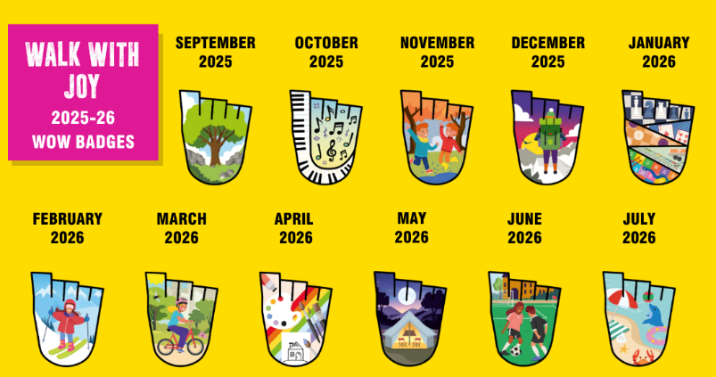
WOW 2025/26 encourages pupils to Walk with Joy, with badges depicting everything from jumping in puddles to painting.

The badges are made in Cornwall from material that was otherwise destined for landfill, including fridge trays, plastic plates and yoghurt pot off-cuts.

For more information, visit: https://www.livingstreets.org.uk/recycling

Last year, around 2,100 schools and over 540,000 pupils across the UK enjoyed the benefits of walking to school with WOW. Will you join us?

If you have any questions about the programme, please contact the school office enquiries@williamgilbertend.derbyshire.sch.uk, or find more information and useful videos at: https://www.livingstreets.org.uk/wowlaunch

Let’s swap those school runs for school walks.

Yours sincerely

Mrs E H Britten
Headteacher

