ARTIST OF THE MONTH April 2026
Artist of the month is a competition that runs in school. Each month we look at a different artist and their work, children can then respond to this artist by either creating a picture, taking a photograph, writing a story, doing some research or a different response that inspires them. Mrs Britten our Art and Design subject lead shares the artist of the month via the school art notice board. The artist of the month winner will be announced at the end of each month.
To enter you need to respond to the artist however you choose. Put your entry into the ‘Artist of the Month’ basket next to the art gallery display or email it to enquiries@williamgilbertend.derbyshire.sch.uk with the title 'Artist of the Month'. Please enter by Thursday 30th April 2026
This month's artist is: Henri Rousseau
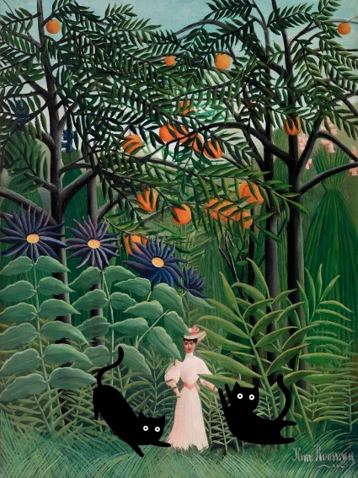
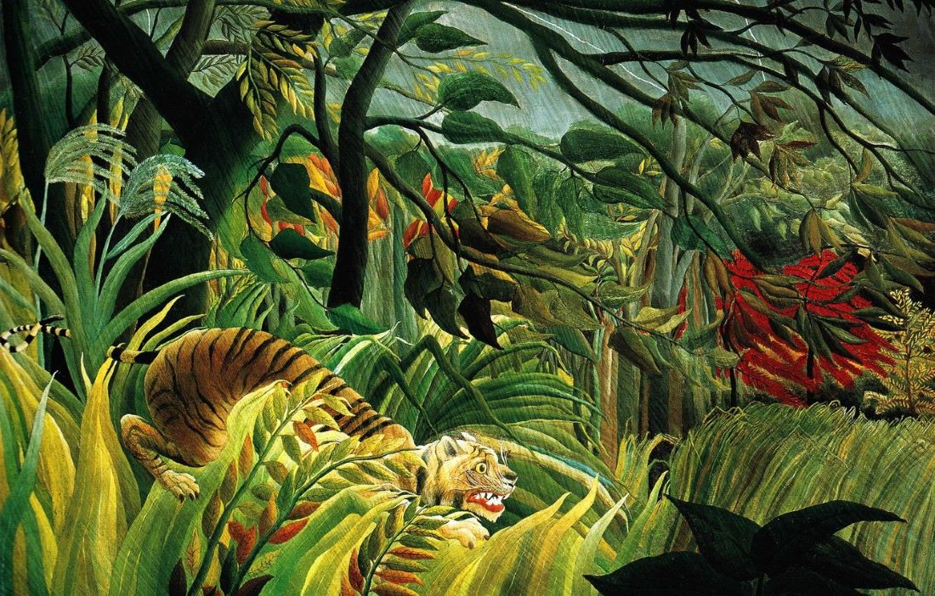

‘Tiger in a Tropical Storm (Surprised!)’ (1891) ‘Woman Walking in an
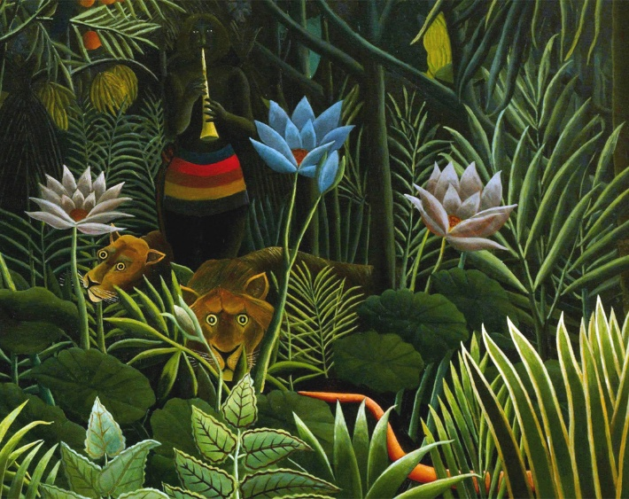
Exotic Forest (1905)
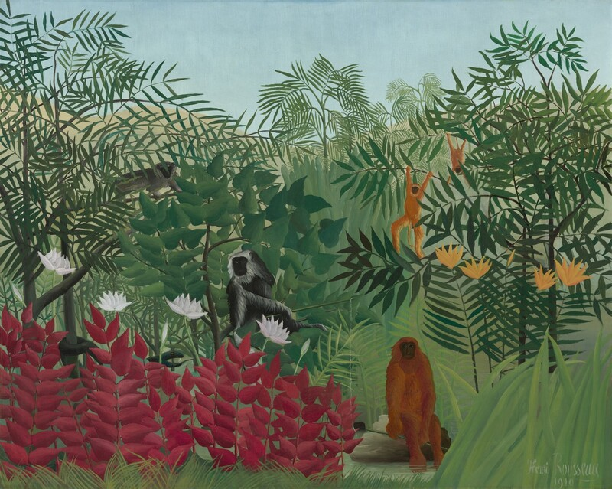

‘The Dream’ (1910) ‘Tropical Forest with Monkeys’ (1910)

About the Artist – Henri Rousseau

Henri Rousseau was a French artist born in 1844. He didn’t train in an art school like many other painters. Instead, he worked as a tax collector, and he painted in his spare time because he loved creating pictures. Rousseau is famous for painting bright, colourful jungle scenes, even though he never visited a real jungle!

He got his ideas from plants in parks, visiting the botanical gardens in Paris, animals in zoos and museums, books, and his own imagination. His paintings often show tall trees, big leaves, unusual flowers and wild animals like lions, monkeys and tigers. When you look at Rousseau’s paintings, you might notice that the shapes are clear and simple. His pictures don’t look realistic like photographs. Instead, they look magical, mysterious and full of imagination. Some people thought his art was strange at the time, but other artists loved how creative and brave he was.

One of his most famous paintings is “Tiger in a Tropical Storm (Surprised!)”, which shows a tiger creeping through a stormy jungle. Rousseau used strong colours and bold patterns to make the scene look exciting and full of movement. Rousseau’s paintings remind us that you don’t have to follow every rule to make great art. You can use your imagination, explore new ideas and create your own world on the page.

Questions to Think About
- Why do you think Rousseau painted jungles even though he never travelled to one?
- What details can you spot in his jungle scenes that make them look magical or unusual?
- How does Rousseau use shapes and colours to make his pictures look bold and eye-catching?
- If you created your own imaginary jungle, what plants or animals would you include?
- How do Rousseau’s paintings make you feel — adventurous, curious or something else?

Now It’s Your Turn!

To celebrate Sir David Attenborough’s 100th birthday, we would like you to create your own animal artwork inspired by the artist Henri Rousseau. Rousseau was famous for painting magical jungle scenes filled with bright colours, huge leaves and amazing animals. Even though he never visited a real jungle, he used his imagination to create exciting pictures full of life and adventure.

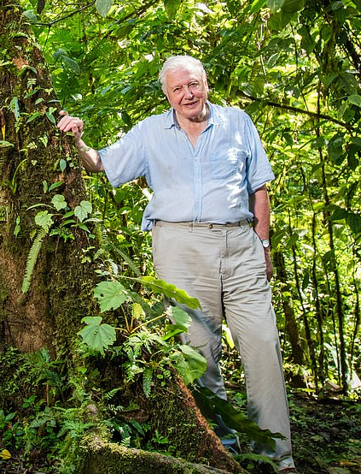
Just like Rousseau, you can design your own wild habitat. Think about where your animal might live — a deep rainforest, a sunny grassland, a snowy mountain or an underwater world. Use bold shapes, strong colours and lots of details in the plants and background to make your picture feel alive.

Sir David Attenborough has spent his whole life helping us learn about the wonderful animals on our planet. This is your chance to celebrate his work by showing the beauty of nature through your own artwork.

Choose any animal you like — a tiger, a lemur, a whale, a chameleon or even an animal nobody has discovered yet! Be creative, be bold, and let your imagination run wild, just like Henri Rousseau.

Here are some ideas:

EYFS
Focus: big shapes, imaginative colour, simple jungle settings
Ideas:
- Collage Jungle Animals: Children cut or tear green paper for leaves and add simple animal shapes on top.
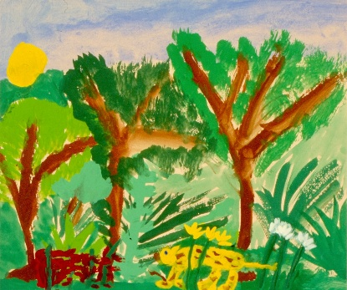
- Finger-Painted Animals: Use fingerprints to create patterns on tigers, snakes or frogs.
- Texture Rubbings: Make leaf rubbings and place an animal drawing on top to create a jungle effect.
- Animal Masks: Decorate tiger, monkey or parrot masks using bright colours, feathers or patterns.
- Hidden Animals: Children draw an animal, then paint or collage leaves partly over it like a “peek-a-boo jungle.”

KS1
Ideas:
- Patterned Jungle Animals: Draw an animal using clear outlines, then fill the body with repeated patterns (stripes, dots, swirls).
- Mixed-Media Jungle Scene: Children create a background with paint, then add cut-out animals on top.
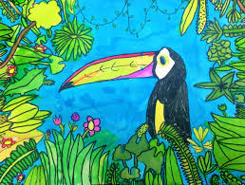
- Watercolour Wash + Crayon Resist: Use crayons for plants and animals, then paint over with green/blue washes.
- Animal Silhouettes: Black animal shapes placed on bright, Rousseau-style jungles.
- Create a New Species: Combine two animals and design an imaginative habitat.

KS2
Ideas:
- Layered Jungle Scene: Build depth by drawing/painting foreground leaves, midground plants and background sky.
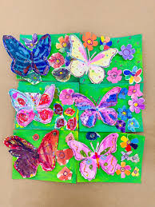
- Study of Animal Textures: Use shading and mark-making to show fur, feathers or scales.
- Perspective Jungle Path: Create a jungle that leads the viewer’s eye into the distance.
- Rousseau-Style Storm Scene: Paint an animal caught in dramatic weather—rain, wind, lightning.
- David Attenborough Tribute Poster: Choose an endangered animal and create a detailed Rousseau-inspired habitat around it.
