ARTIST OF THE MONTH march 2026
Artist of the month is a competition that runs in school. Each month we look at a different artist and their work, children can then respond to this artist by either creating a picture, taking a photograph, writing a story, doing some research or a different response that inspires them. Mrs Britten our Art and Design subject lead shares the artist of the month via the school art notice board. The artist of the month winner will be announced at the end of each month.
To enter you need to respond to the artist however you choose. Put your entry into the ‘Artist of the Month’ basket next to the art gallery display or email it to enquiries@williamgilbertend.derbyshire.sch.uk with the title 'Artist of the Month'. Please enter by Friday 27th March 2026
This month's artist is: Georges Seurat
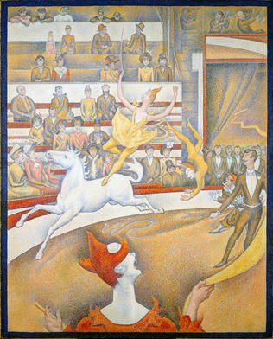
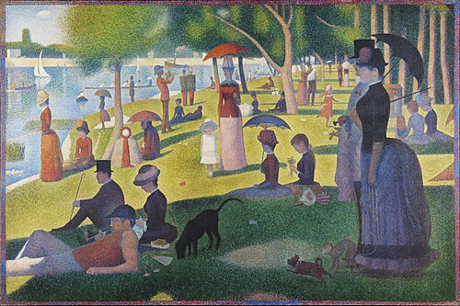

A Sunday Afternoon on the Island of La Grande Jatte’ ‘The Circus’
(1884–1886) (1881)

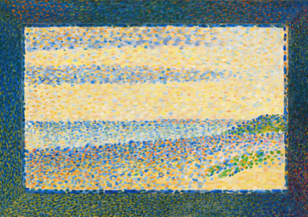
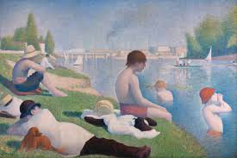

‘Bathers at Asnières’ (1884) ‘Seascape’ (1890)

About the Artist – Georges Seurat
Georges Seurat was a French artist born in 1859 in Paris. He is famous for creating a brand-new style of painting called Pointillism. Instead of using brushstrokes like other artists, Seurat painted using tiny dots of pure colour. When you stand close to his paintings, you can see all the separate dots — but when you step back, the colours blend together, and your eyes mix them into new shades. This idea was very new and very exciting at the time!
Seurat loved studying science and colour. He believed that colours look brighter and more powerful when they are placed next to their opposites, like blue next to orange or red next to green. His most famous painting, “A Sunday Afternoon on the Island of La Grande Jatte,” took him over two years to complete because he carefully placed millions of tiny dots.
He often painted people relaxing by rivers, parks and beaches, showing everyday life in France. Even though his paintings look calm, they were created with great focus, patience and skill. Sadly, Seurat died very young at just 31 years old, but his ideas changed art forever and inspired many other painters.
Questions to Think About
- Why do you think Seurat chose to paint with tiny dots instead of brushstrokes?
- How do the colours change when you look at his paintings up close compared to far away?
- What kind of scene would you create using dots of colour?
- How does Seurat show light, shadow and movement using only dots?

Now it’s your turn

Now It’s Your Turn!
Create a piece of art inspired by Georges Seurat. Here are some ideas:

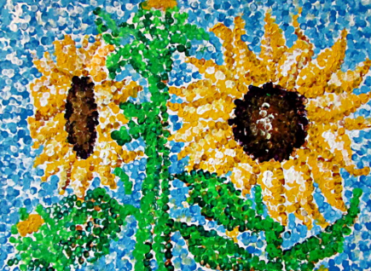
EYFS / KS1 Ideas
- Dot Painting with Cotton Buds
Dip cotton buds into bright paint and create a simple picture using dots: a tree, a sun, a flower or a boat.
- Dot Patterns
Make a rainbow, shape picture or animal using only dots of felt-tip pens.

KS2 Ideas
- Pointillism Landscape
Draw a simple scene (river, park, beach). Colour it in using tiny dots of felt-tip.
- Complementary Colour Challenge
Choose two opposite colours (e.g. blue/orange) and see how using dots of each can make your picture look brighter.
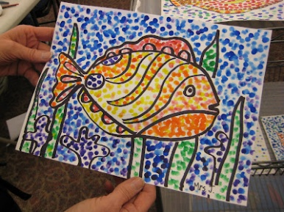
- Dot Portrait or Silhouette
Create a silhouette (like a person or animal) and fill it with dots of colour to show shading.

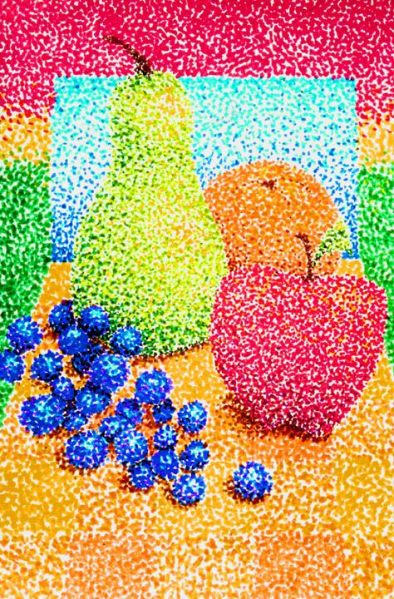

More inspiration

Here are some links to ‘how to videos’ on YouTube. Please ask an adult before you scan the QR code or click the link to watch the video with an adult.

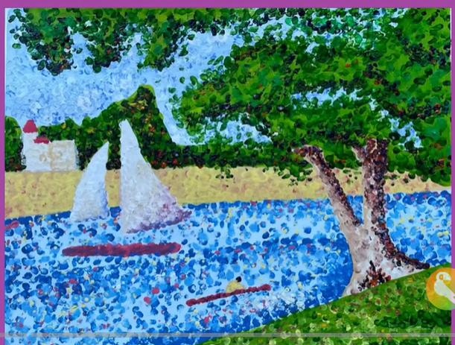

https://www.youtube.com/watch?v=Sf0kZqQFZAw


https://www.youtube.com/watch?v=sAPJ2q3Qa_k
