ARTIST OF THE MONTH JUNE 2026
Artist of the month is a competition that runs in school. Each month we look at a different artist and their work, children can then respond to this artist by either creating a picture, taking a photograph, writing a story, doing some research or a different response that inspires them. Mrs Britten our Art and Design subject lead shares the artist of the month via the school art notice board. The artist of the month winner will be announced at the end of each month.
To enter you need to respond to the artist however you choose. Put your entry into the ‘Artist of the Month’ basket next to the art gallery display or email it to enquiries@williamgilbertend.derbyshire.sch.uk with the title 'Artist of the Month'. Please enter by Tuesday 30th June 2026
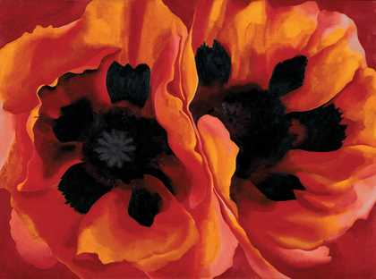
This month's artist is: Georgia O’Keeffe
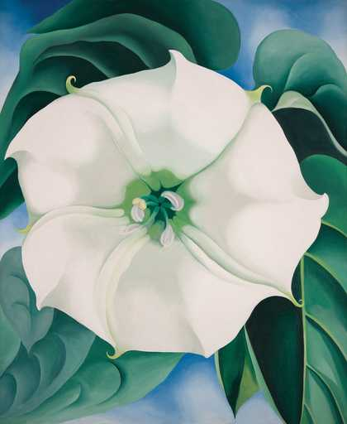

‘Oriental Poppies’ (1927)

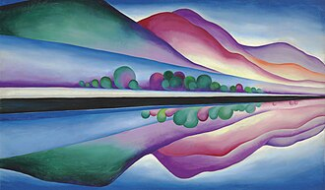
‘Cerimônias Femininas ’ (2022)

‘White Flower Number I’ (1932)

‘Lake George Reflection (1922)

About the Artist – Georgia O’Keeffe

Georgia O’Keeffe was an American artist who was born in 1887 and became one of the most famous painters of the 20th century. She is best known for her large paintings of flowers, landscapes and natural objects. O’Keeffe spent much of her life exploring the beauty of the world around her, especially the deserts, mountains and skies of New Mexico in the United States.
One of the things that made Georgia O’Keeffe’s artwork special was the way she looked closely at ordinary objects. She often painted flowers much larger than they appear in real life, filling the canvas with petals, shapes and colours. By making her paintings so big, she encouraged people to slow down, and notice details they might usually miss.
O’Keeffe was inspired by nature and believed that there was beauty in simple things. She painted bones, shells, leaves, hills and clouds, carefully observing their shapes and colours. Although her paintings were based on real objects, she often simplified forms and used smooth areas of colour to create bold and striking images.
When you look at Georgia O’Keeffe’s artwork, you may notice that some paintings feel calm and peaceful, while others seem dramatic and powerful. She used colour, shape and scale to help viewers experience nature in a new way.
Georgia O’Keeffe’s art reminds us that inspiration can be found everywhere. By taking time to look closely at the world around us, we can discover beauty, detail and wonder in even the simplest objects.
Questions to Think About
• Why do you think Georgia O’Keeffe painted flowers much larger than they appear in real
life?
• What details can you notice when you look closely at her paintings?
• How do the colours and shapes make you feel?
• Why might an artist choose to focus on one small part of an object rather than showing
the whole thing?
• If you looked closely at something from nature, what would you choose to paint and why?

If you made your own artwork inspired by Milhazes, what colours and patterns would you choose?

Now It’s Your Turn!

This month, our Artist of the Month is Georgia O’Keeffe, an American artist famous for her beautiful paintings of flowers, landscapes and objects from nature. She was inspired by the natural world around her and encouraged people to slow down and notice the beauty in everyday things.

Georgia O’Keeffe often painted flowers much larger than they appear in real life, filling the canvas with petals, shapes and colours. By zooming in on small details, she helped people see familiar objects in a completely new way. Her artwork is bold, simple and carefully observed, showing just how interesting nature can be when we take time to look closely.
Your challenge is to create artwork inspired by the natural world. You might choose a flower, leaf, shell, feather or another object from nature and look at it carefully before creating your artwork. Try zooming in on a small section, making it much larger than life, or filling your page with colour, shape and detail.

Take your time, observe carefully and discover the beauty in the world around you — just like Georgia O’Keeffe.

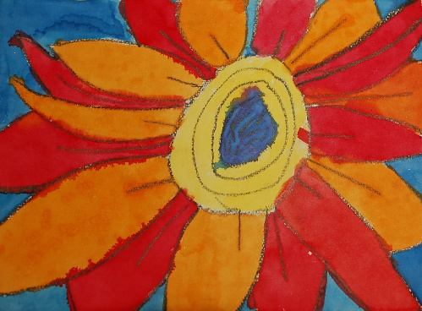

Some Ideas to Get You Started
EYFS
Ideas:
• Giant Flower Paintings: Paint large flowers that fill the whole page, using bright colours and simple shapes.
• Petal Printing: Use sponges, bottle tops or fingers to print flower petals and create colourful blooms.
• Nature Close-Ups: Look carefully at leaves, flowers or shells and draw the shapes you can see.
• Flower Collages: Cut and arrange paper petals to make oversized flowers inspired by Georgia O’Keeffe’s paintings.

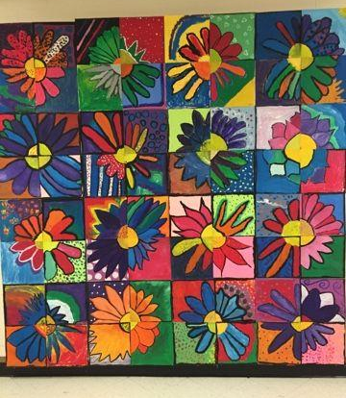
KS1
Ideas:
• Zoom-In Flowers: Choose a flower and draw only a small section of it, making it much larger than real life.
• Pastel Petals: Use oil pastels and paint to create colourful flower petals with blended colours.
• Nature Patterns: Explore the lines and shapes in leaves, feathers or shells and turn them into artwork.
• Looking Closely: Use a magnifying glass to study a natural object before drawing it.

KS2
Ideas:
• Georgia O’Keeffe Flower Paintings: Create large-scale flower artworks that fill the page and focus on shape, colour and detail.
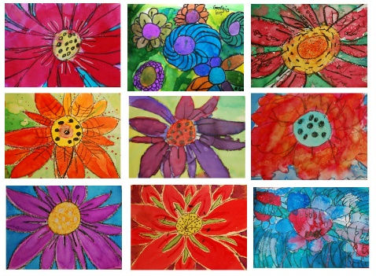
• Nature Magnified: Enlarge a small part of a leaf, shell, feather or flower and recreate it on a larger scale.
• Bold Landscapes: Explore O’Keeffe’s desert landscapes and create simplified paintings using colour and shape.
• Observational Art: Study natural objects carefully and use shading, blending and colour mixing to capture their details.

Remember:
Georgia O’Keeffe showed us that ordinary objects can become extraordinary when we take time to look closely. There is beauty in the small details of nature all around us. Slow down, observe carefully and see what interesting shapes, colours and patterns you can discover.

