ARTIST OF THE MONTH september 2026
Artist of the month is a competition that runs in school. Each month we look at a different artist and their work, children can then respond to this artist by either creating a picture, taking a photograph, writing a story, doing some research or a different response that inspires them. Mrs Britten our Art and Design subject lead shares the artist of the month via the school art notice board. The artist of the month winner will be announced at the end of each month.
To enter you need to respond to the artist however you choose. Put your entry into the ‘Artist of the Month’ basket next to the art gallery display or email it to enquiries@williamgilbertend.derbyshire.sch.uk with the title 'Artist of the Month'. Please enter by Wednesday 30th September 2026
This month's artist is: Quentin Blake
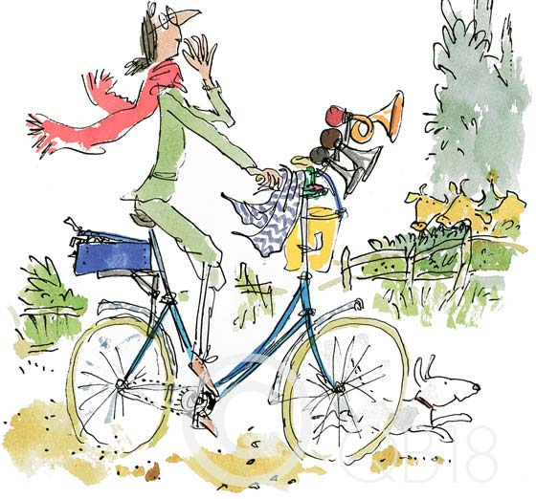
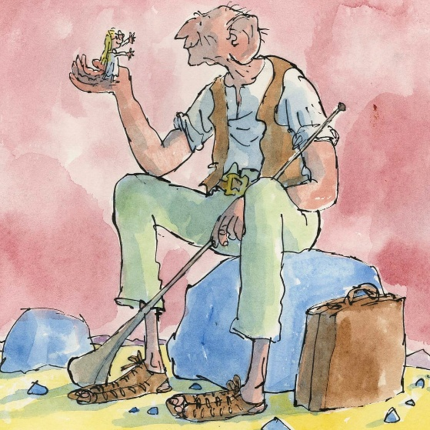

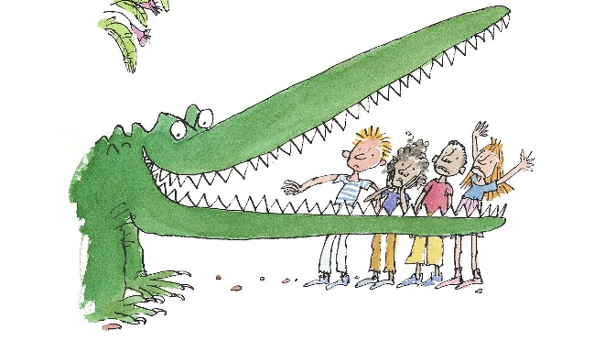
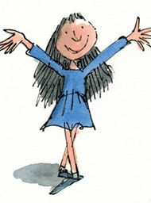

About the Artist – Quentin Blake

Quentin Blake is a British illustrator, author and artist who was born in 1932. He is one of the most famous illustrators in the world and has illustrated more than 500 books. Many children know his work from the stories of Roald Dahl, but he has also written and illustrated his own books, including Mrs Armitage on Wheels.
Quentin Blake's drawings are instantly recognisable because of their lively, sketchy lines and sense of movement. His characters often look as though they are rushing, leaping, wobbling or dashing across the page. Rather than making every line perfect, he uses quick marks, expression and humour to bring his illustrations to life.
One of Quentin Blake's most popular characters is Mrs Armitage, an inventive cyclist who is always thinking of new gadgets and improvements for her bicycle. As we take part in Cycle September, his artwork reminds us of the fun, freedom and adventure that cycling can bring. His illustrations also show us that creativity is about imagination and ideas, not just drawing perfectly.
Quentin Blake encourages us to be brave, experiment and enjoy the creative process. His work shows that a few simple lines can tell a story, capture movement and make us smile.
Questions to Think About
- How does Quentin Blake make his characters look as though they are moving?
- What do you notice about the lines he uses?
- Why do you think his drawings feel full of energy and action?
- If you could add one invention to Mrs Armitage's bicycle, what would it be?
- How can an illustration tell a story without using many words?

Now It's Your Turn!
This month our Artist of the Month is Quentin Blake, the famous illustrator behind Mrs Armitage on Wheels. His drawings are full of movement, imagination and humour. He shows us that art does not have to be perfect to be powerful.

Your challenge is to create a piece of artwork inspired by movement, cycling or invention. You might draw a character on a bicycle, design an exciting new gadget for Mrs Armitage's bike, create a comic-strip adventure, or invent your own environmentally friendly active-travel vehicle.

Think carefully about how Quentin Blake uses line, expression and movement to bring his characters to life. Can you create artwork that tells a story and makes people smile?

For further information and inspiration you could watch this short video of Quentin Blake in his studio drawing.
Quentin Blake in his studio

https://www.youtube.com/watch?v=ZQn8Qc_P6SA

Watch the animated film of Mrs Armitage on Wheels on BBC iPlayer (28 minutes long)

https://www.bbc.co.uk/iplayer/episode/m001xxqf/mrs-armitage-on-wheels


Watch a ‘How to draw Mrs Armitage on Wheels’
https://www.youtube.com/watch?v=U50mcvGaVbo

Ideas for
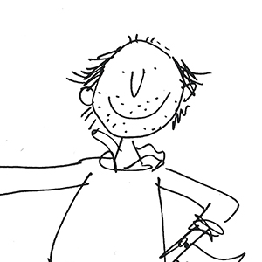
EYFS
Wiggly Lines and Moving Bikes
- Explore different marks and lines using large paper.
- Draw people riding bicycles using movement lines.
- Design one fun addition for Mrs Armitage's bike.
- Create bicycle pictures using paint, collage or chalk.
Other Ideas
- Draw a journey to school.
- Use playdough to create bicycles and riders.
- Build imaginative bicycles using construction toys.

KS1
Mrs Armitage's Brilliant Bicycle
- Read Mrs Armitage on Wheels.
- Design a bicycle with three new inventions.
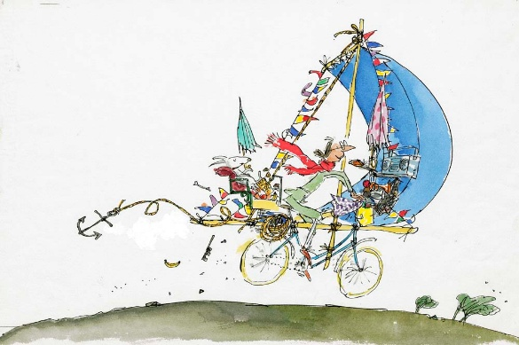
- Include Mrs Armitage and Breakspear.
- Add labels explaining what each invention does.
Other Ideas
- Create a moving bicycle collage.
- Draw a funny cyclist using Quentin Blake's style.
- Make a poster encouraging children to cycle or scoot to school.

Lower KS2
An Illustrated Adventure
- Create a three or four panel comic strip showing a cycling adventure.
- Include a problem, invention and solution.
- Use movement lines and expressive characters.
Other Ideas
- Illustrate a journey through Duffield.
- Write and illustrate a short story about a magical bicycle.
- Design a cycling route map with humorous landmarks.

Upper KS2
The Ultimate Active Travel Machine
- Design an innovative, environmentally friendly vehicle inspired by Mrs Armitage.
- Produce sketches, annotations and a final illustration.
- Explain how it works and why it encourages active travel.
Other Ideas
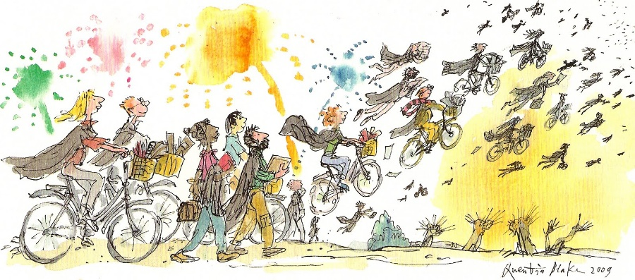
- Investigate how Quentin Blake uses line and movement in famous illustrations and apply these techniques to your own work.
